



*A Marist Swimming & Diving Team Database Proposal*

*------------------------------------------*

*By: Harris Nagle*

*Table Of Contents - - - - - - - - - - - - - - - - - - -*

* Executive Summary---------------------------------------------- 1
* Entity Relationship Diagram ------------------------------------- 2
* Tables/Sample Data ----------------------------------------- 5 -19
* Views ---------------------------------------------------------- 21
* Stored Procedures ---------------------------------------------- 22
* Reports (Sample Data/ Queries) ---------------------------- 23-24
* Security (Grant/Evoke privileges)------------------------------- 25
* Future Enhancements ------------------------------------------ 26
* Implementation Notes ------------------------------------------ 27
* Known Problems ----------------------------------------------- 28

*Executive Summary - - - - - - - - - - - - - - - - -*

The Marist College Swimming & Dive Team is one of the most highly accomplished teams that Marist College has to offer. Collectively the men and women’s program has acquired 28 of the schools 103 Metro Atlantic Athletic Conference championship titles, more than any other athletic program. The swim & dive team has massive amounts of data and records that must be kept stored in an orderly manner. This data also must be accessible so that the coaching staff may access it for creating competition entries without any inaccuracies within the data

The current issue with this process is that the swim & dive team uses a paper-pencil procedure and has a reliance on Red Fox Aquatic Club’s Hy-Tek Sports Software. This software helps create paper print outs that the coaching staff utilizes when deciding entries. This makes the workload for swim coach VanWagner and diving coach Bolstad monumental, especially when selecting championship entries for all 45 athletes. The coaching staff needs a better way to gather, organize, and distribute its data in a more efficient manner.

The Marist Swim-NET is a system designed to organize times and scores for swimmers and divers. Overall this system was designed in order to ease the amount of work for the coaching staff, and allow the athletes themselves to see exactly where they stand on the team based on their score or time. This new system is designed to make the process of creating programs for competitions, and keeping tack of scores and times completely run/managed by the coaching staff. This system will help sophisticate and separate Marist College Swimming & Diving from any other team at Marist in terms of organization. This database was made on PostGres MySQL.

*Entity Relationship Diagram - - - - - - - - - - - - -* This ER-Diagram was made with Draw.io ***

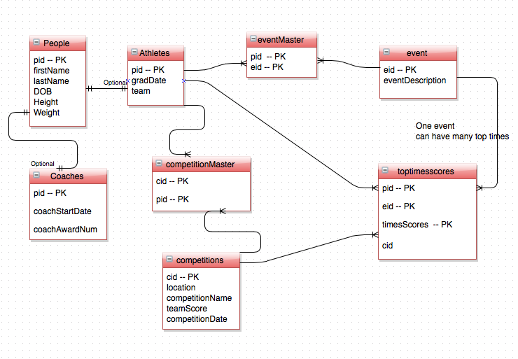

*People Table -----------------------------------*

The People table is designed to include everyone on the roster and coaching staff of the Marist Swimming and diving team. It also contains the stats of all the people apart of the coaching staff and team. It shows their first name, last name, date of birth (D.O.B), sex, height, and weight. This is essential to have in the Marist Swim-NET so that the coaching staff can easily look up an athlete using the people ID (pid), and see their stats. This will make it more efficient in the recruiting process because the coach can quickly look up where a potential athlete would fit on the team.

*FUNCTIONAL DEPENDENCIES* *--------------------------------*

PRIMARY KEY 🡪 pid (peopleid)

*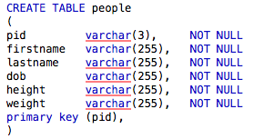CREATE STATEMENT-------------------------------------*

*SAMPLE DATA FOR PEOPLE TABLE -----------*

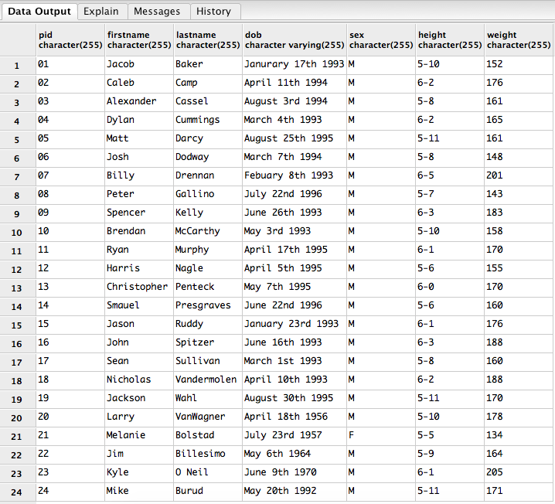

*Coaches Table ----------------------------------*

The Coaches table is designed to keep track of how long coaches have been coaching the marist swimming and diving team by storing their start date through the coachStartDate attribute. It also helps keep track of how many awards they have acquired throughtout their coaching career through the coachAwardNum. It is also useful for potential recruits to look up and see how much expeirience they have coaching the team, because with more expierience means more wisdom and that is attractive to potential new athletes.

*FUNCTIONAL DEPENDENCIES -------------------------------*

Primary Key 🡪 people id (pid)

*CREATE STATEMENT -------------------------------------*

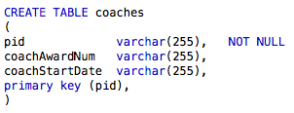

*SAMPLE DATA FOR COACHES TABLE------------*

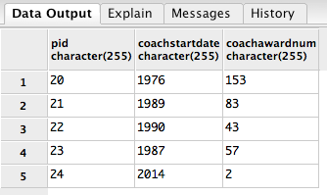

*Athlete Table ------------------------------------*

The Athlete table is designed to organize and separate all the athletes out of the people table and away from the coaches. They athletes are organized by their people id (pid), gradDate, and team. The gradDate attribute is important because it will help the coaching staff see what class in school they are in, meaning if the athlete is currently a freshman they will have 2018 next to their pid. The team attribute is important because coaches call up a call for all the swimmers on the team instead of all the swimmers and divers together in their result.

*FUNCTIONAL DEPENDENCIES --------------------------------*

Primary Key 🡪 people id (pid)

*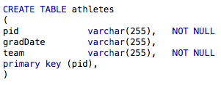CREATE STATEMENT -------------------------------------*

*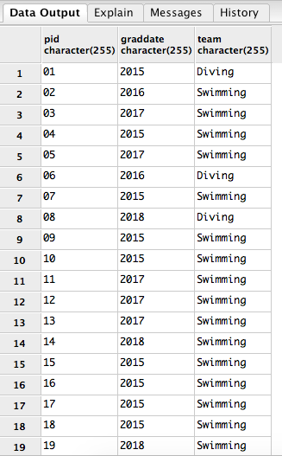SAMPLE DATA FOR ATHLETES TABLE -----------*

*Event Master Table ------------------------------*

The eventMaster table is designed to compile all the athletes based on their people.id and the events that they have been entered in throughout multiple competitions during the season. This table is useful to the coaching staff because it will help them figure out what athletes were in what events throughout the season. This feature comes in handy when they have to decide what events an athlete is going to do at one of our championship competitions.

*FUNCTIONAL DEPENDENCIES --------------------------------*

Primary Key 🡪 event.id (eid – comes from event table), people.id (pid)

*CREATE STATEMENT -------------------------------------*

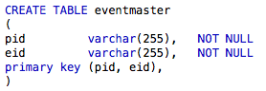

*SAMPLE DATA FOR EVENTSMASTER TABLE -----*

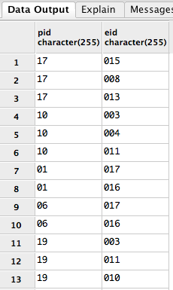

*Event Table -------------------------------------*

The event table is designed to be the archive of event id’s (eid) and people id’s (pid) provided by the athletes’ table. This table is helpful to the coaching staff because it contains all the individual events available to enter one of their athletes into. The table contains and event id for each event and an eventDescription to go with the eid which shows the title/name of the event.

*FUNCTIONAL DEPENDENCIES --------------------------------*

Primary Key 🡪 event id (eid)

*CREATE STATEMENT -------------------------------------*

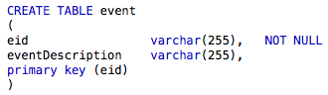

*SAMPLE DATA FOR EVENT TABLE ---------------*

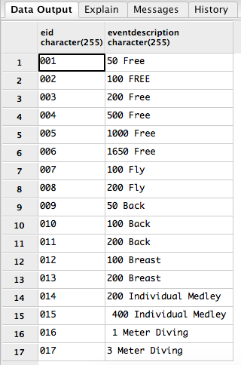

*Competition Master Table -----------------------*

The competition master table is designed to keep hold of what athletes are going to what specific competitions they have already competed in. Competitions are organized through a competition id (cid), and they are linked with a people id (pid). This is useful for the coaching staff when they have to decide a championship roster, which is limited to 18. This will table will help them decide if an athlete has had enough racing this season to even be considered being entered into a championship competition and being one of the select 18.

*FUNCTIONAL DEPENDENCIES --------------------------------*

Primary Key 🡪 competition id (cid), people id (pid)

*CREATE STATEMENT -------------------------------------*

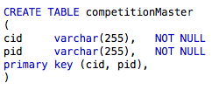

*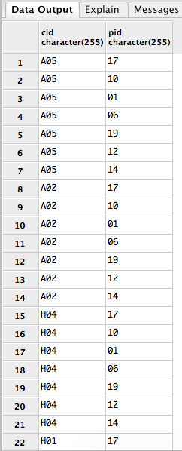SAMPLE DATA FOR COMPETITION MASTER TABLE -----------------------------------------*

*Competitions Table -----------------------------*

The Competition table was created to store the actual competitions and their data. The data that corresponds with a competition would its competition id (cid), location, competitionName, teamScore, and competitionDate. All these attributes clarify when the competition happened, where it happened, whether we won or lost, and who the competition was against. This is useful when the staff is preparing the schedule for next season and they would like to reflect back on the previous season so they can maybe pick the same weekends to have competitions.

*FUNCTIONAL DEPENDENCIES --------------------------------*

Primary Key 🡪 competition id (cid)

*CREATE STATEMENT -------------------------------------*

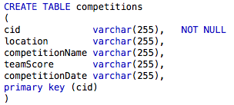

*SAMPLE DATA FOR COMPETITIONS ------------*

*Toptimesscores Table ---------------------------*

The toptimesscores table is designed to store all of the top times swum or dove by athletes at any competition through out the season. It is organized by people id(pid), event id(eid), timesScores, and competition id (cid). The main attribute in this table that makes it unique is the timesScores column. This specific column contains all the fastest times swum in and event during the season. This will be useful for the coaching staff because they can visually see where they have plenty of fast men in events compared to events where the team is weaker in and will need to recruit from.

*FUNCTIONAL DEPENDENCIES --------------------------------*

Primary Key 🡪 people id (pid), event id (eid), timesScores

*CREATE STATEMENT -------------------------------------*

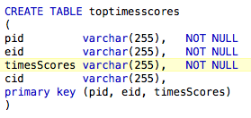

*SAMPLE DATA FOR TOPTIMESSCORES ----------*

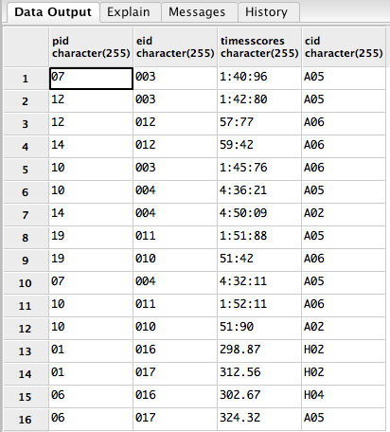

*Views ------------------------------------------*

This view, once run, will display a specific athlete and their best times from any events they swim. This is useful for the coaches because they will be able to see where a specific athlete compares to incoming and current team members.

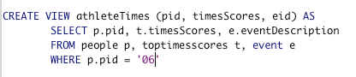

This specific version of the view calls upon the pid of ‘06’. When run it will return this…

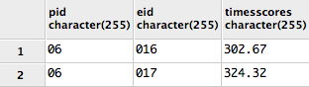

*Stored Procedures -------------------------------*

The getAthletesInfo stored procedure is designed to call upon a specific athlete using their pid. This is useful when coaches are wanting to look up and athlete and don’t want to write a full query. This stored procedure takes less time and less keystrokes for our coaching staff to do.

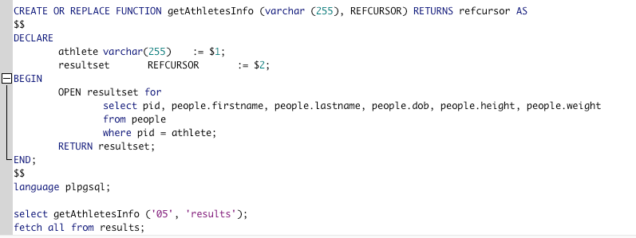

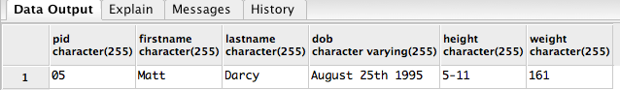

*Reports -----------------------------------------*

**Competitions Attended by Athletes**

This will display all of the competitions and which athletes have participated in them. It will do this because when I call upon the competition master table there are pid’s and cid’s where the cid’s correspond with the competitions and they will match up with an athlete if they have participated in.

**This is the general query to get all the information from the competitionmaster table.**

Screen Shot 2015-05-01 at 3.29.58 PM.png

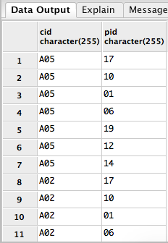

The results here show all of the competitions

that any athlete attended during the season. Here we

can see the for the MAAC Championships we had 7

athletes attend. We can see that because there are

7 A05’s listed in the cid column.

*Reports -----------------------------------------*

**Competitions Attended by Athletes**

This is a more specific query than the previous one. This report will help coaches see exactly what competitions a specific athlete attended during the season.

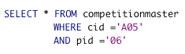

This specific athlete ‘06’ is Josh Dodway a Diver on the team. And we are checking to see if he attend the MAAC championships in Buffalo because the cid =’A05’

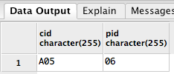

The results show that Josh Dodway did in fact attend the MAAC championships held in Buffalo NY. The coaching staff can use this query for when they need to look any competition information for any athlete on the team.

*Security -----------------------------------------*

There are two different types of users for this database as specified below by the following Grant commands

1. The admin who can change, update, and maintain the database through its life cycle.

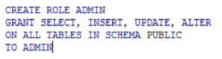

2. The public user who can see and utilize the database by performing queries on it to get their desired information.

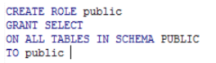

*Future Enhancements----------------------------*

One of the possible future enhancements would be to include the women’s entire roster. The women’s swimming and diving team is a very big part of our team and we are proud to swim along side them in practice. Having the women’s team included in the Marist Swim-NET would make it much more useful to the coaching staff. If they were added to the database if would make the database more useful for recruiting not only men but also other potential women athletes. This will maximize the coach’s time when they are looking up where we have depth deficiencies and need to recruit new potential athletes. This will make our recruiting procedure become faster and more efficient making us able to reach out to faster prospects. This will ultimately make the Marist Swimming & Diving Team become even more competitive in the MAAC conference and an overall faster team.

Another future enhancements would be the possibility of creating a login, username, and password table. That way athletes can look at their own best times in all of their events. Having an account would help personalize the database to its people who

*Implementation Notes---------------------------*

The implementation process for the Marist Swim-NET was very complex considering I was foolish and didn’t save my .sql file in more than one location. Other than that, I had a great time looking up people’s times and where they performed at their best. Swimming is a passion of mine and I really appreciate the hard work and dedication the coaches put in to running a mid major division 1 program. I thought maybe a system designed to make their jobs a little easier would be a nice thing to do. After all they put up with 45 “adults” everyday from August to April and control their temper. This system will hopefully make their recruiting process easier and more efficient.

*Known Problems --------------------------------*

A known problem with this database is that Initially I intended it to be used by the coaches and athletes. I did not address the athletes being able to use this system. They would need a username and password to access the database and its information. Another known problem is that the coach wont be able to find a list of specific athletes and their best times in all the events they’ve been entered in. This would be a key feature for coaches so that they could see new events where they could enter an athlete into; shake up the original line up so to speak.